# Approach document

Approach for watching schema changes in AWS S3 and updating it to audit table in DynamoDB

**     **

## S3 bucket

Create a new S3 bucket where all relevant files will get saved.

Configuration – basic

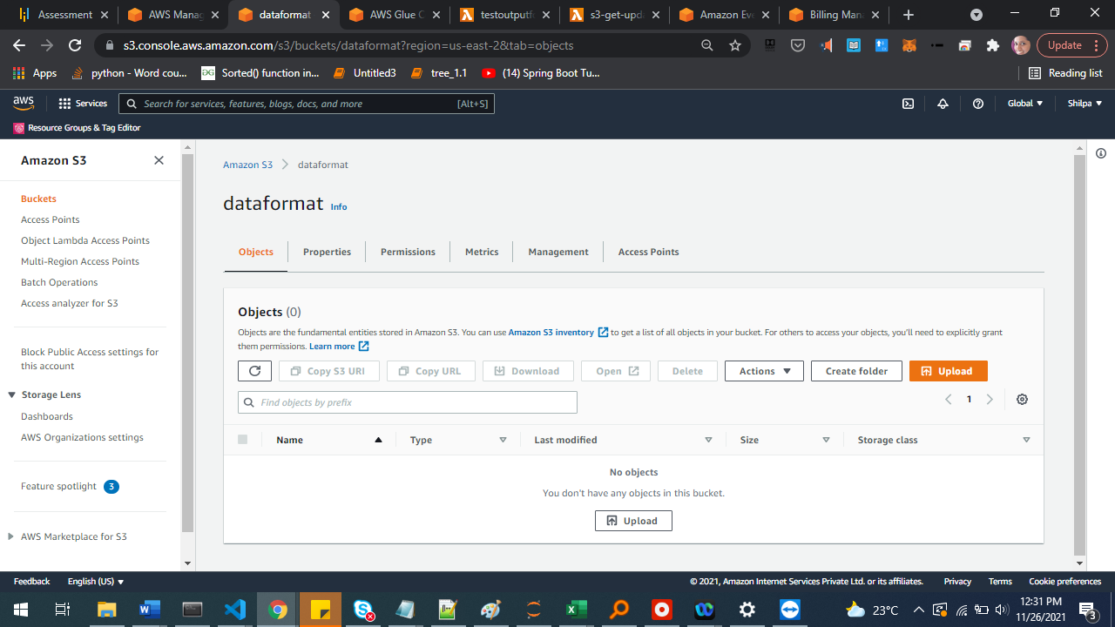

Create one folder each for a file type. For example, all mfg.json files will be put to this folder and one schema will be maintained for this mfg.json in the audit table.

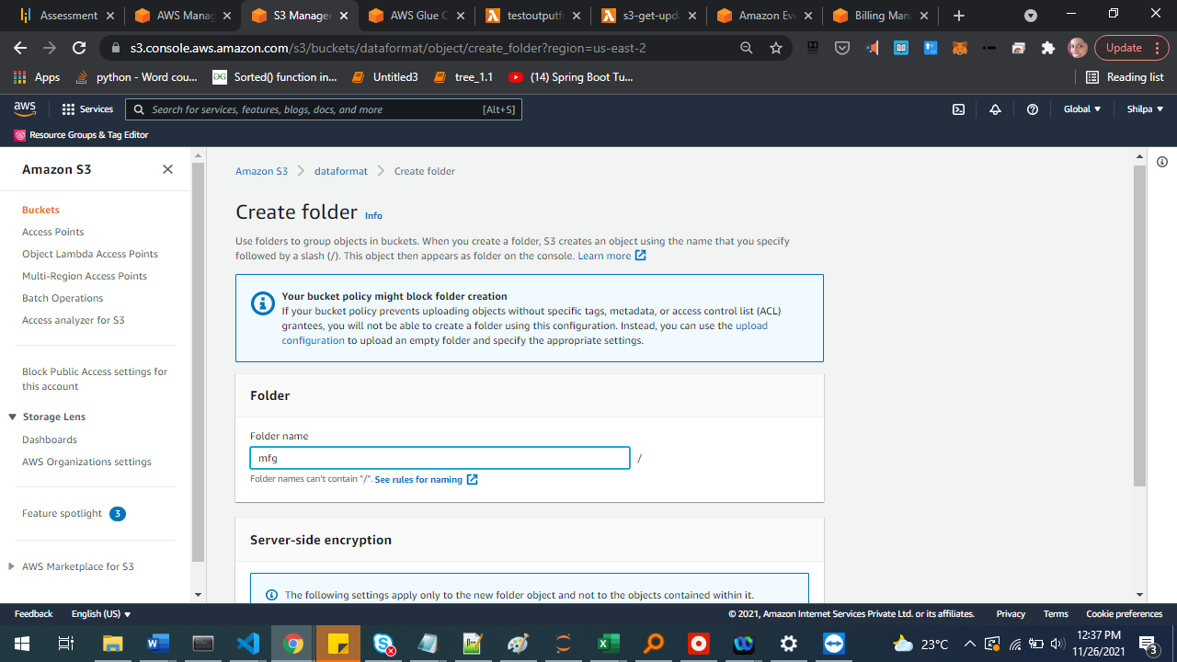

## Glue table using Glue Crawler

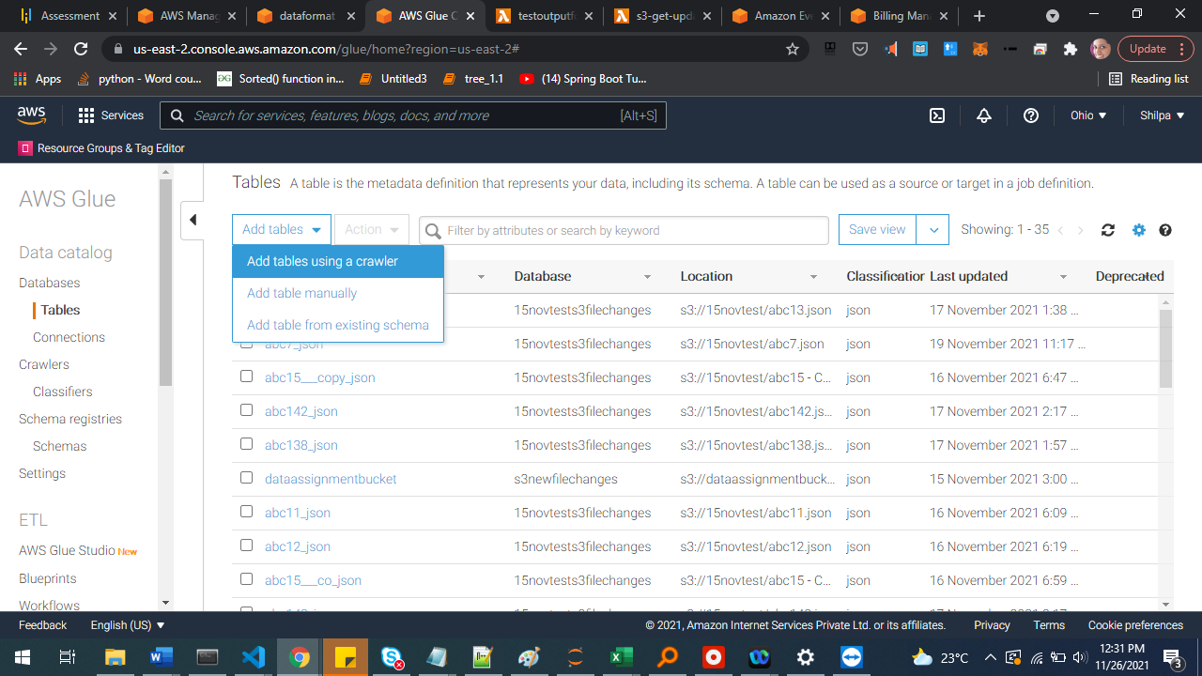

Configuration:

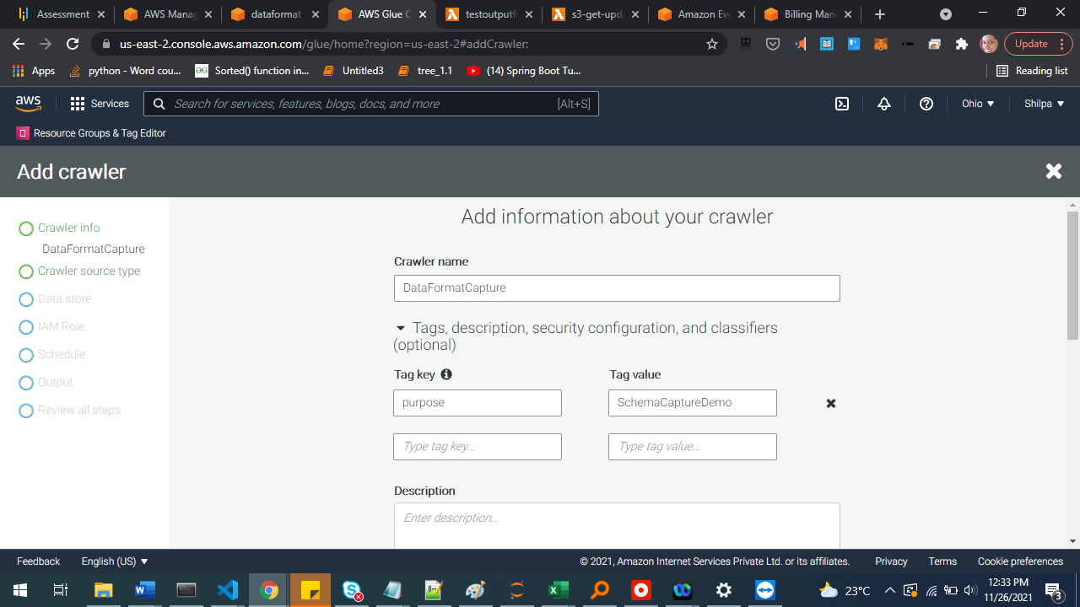

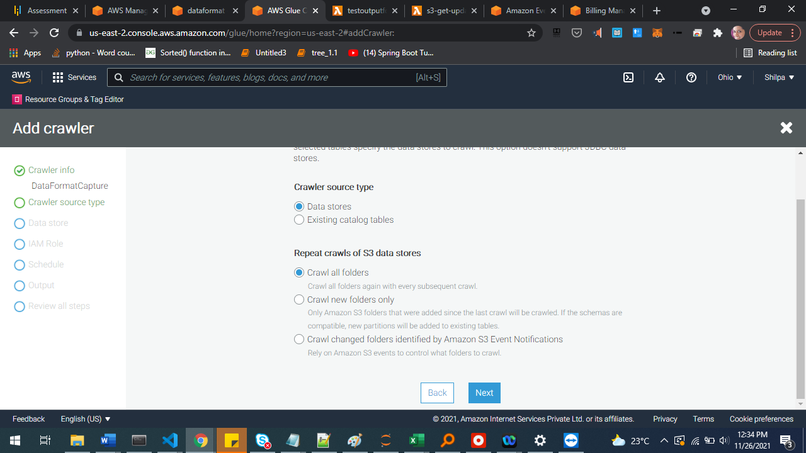

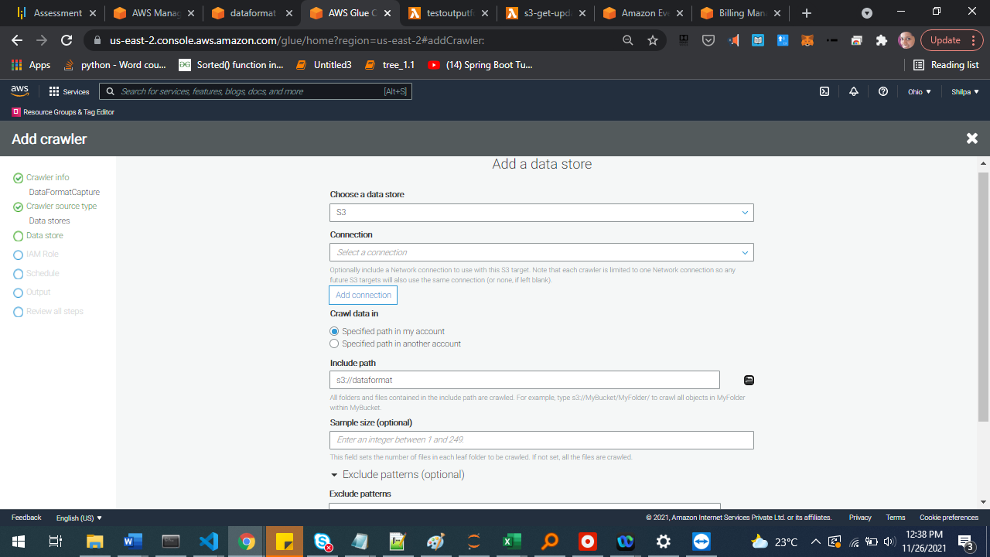

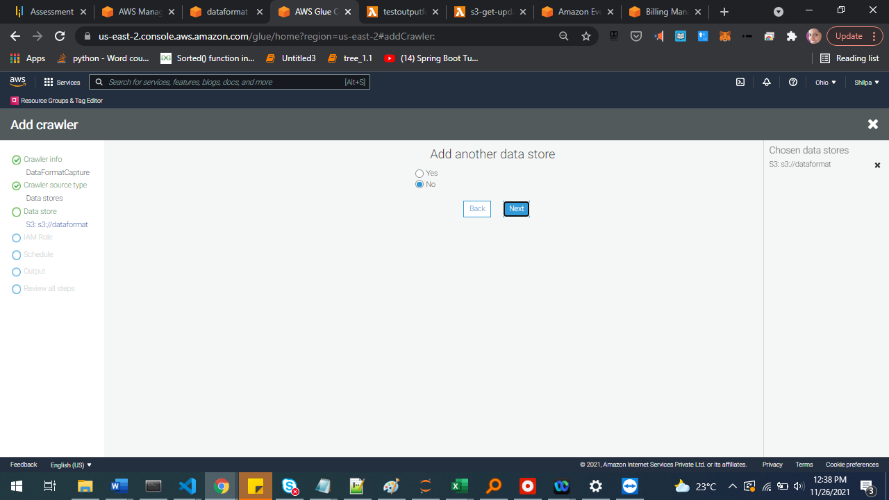

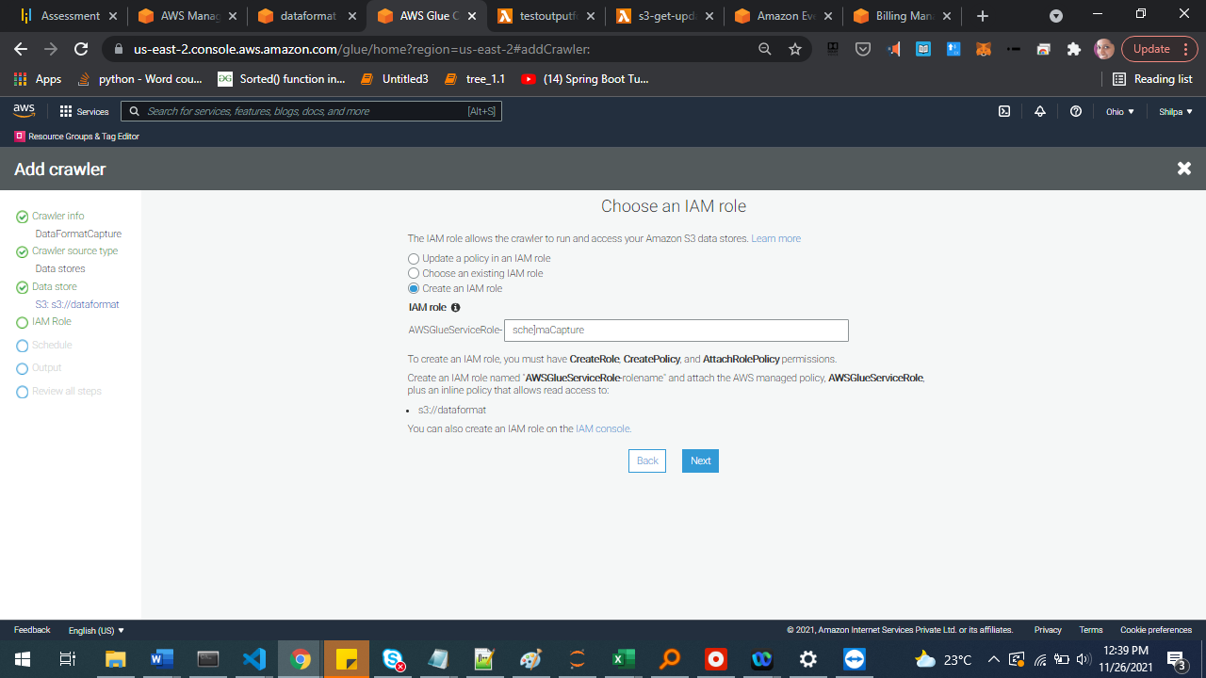 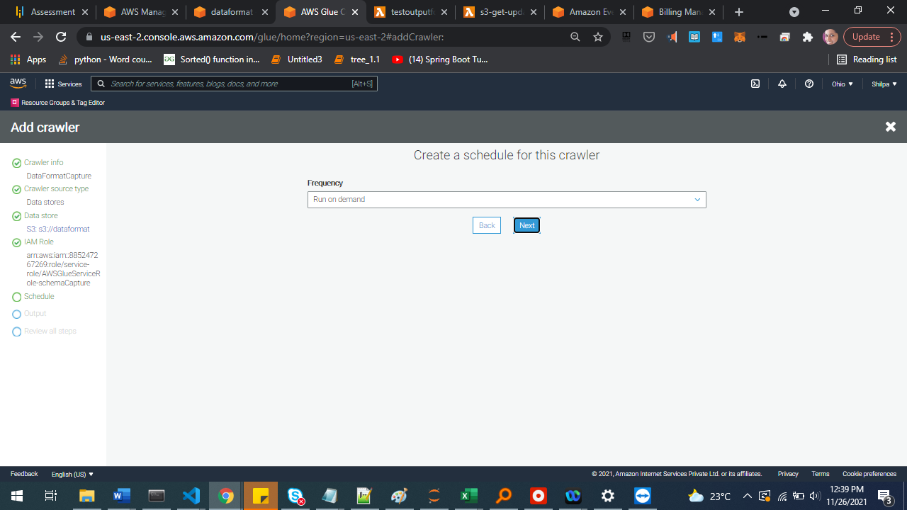

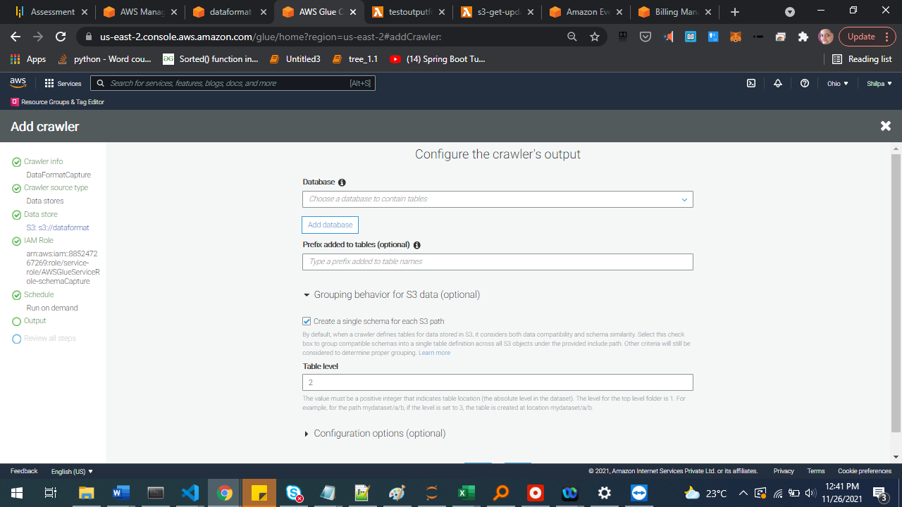

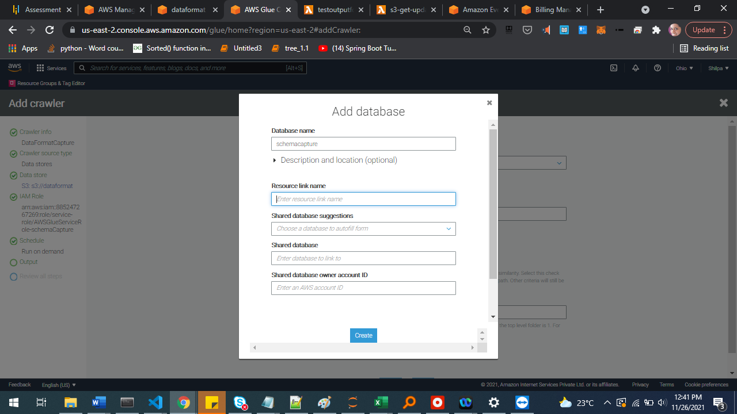

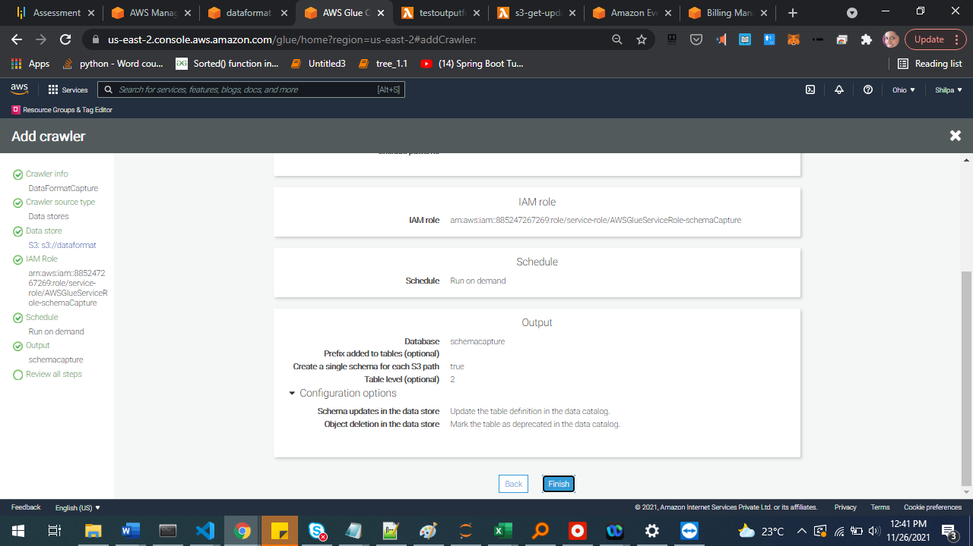

### Test Crawler

Upload file to S3

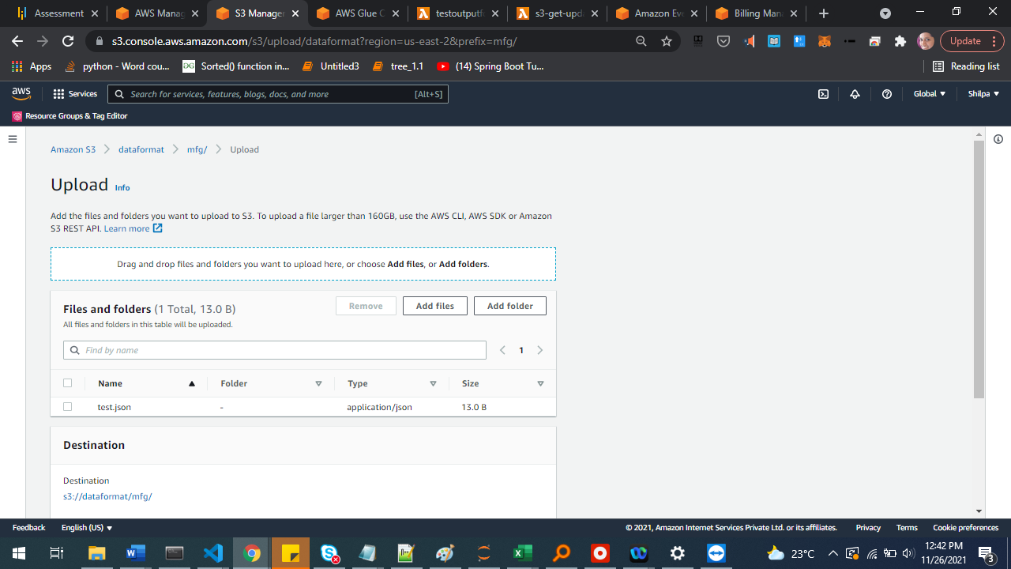

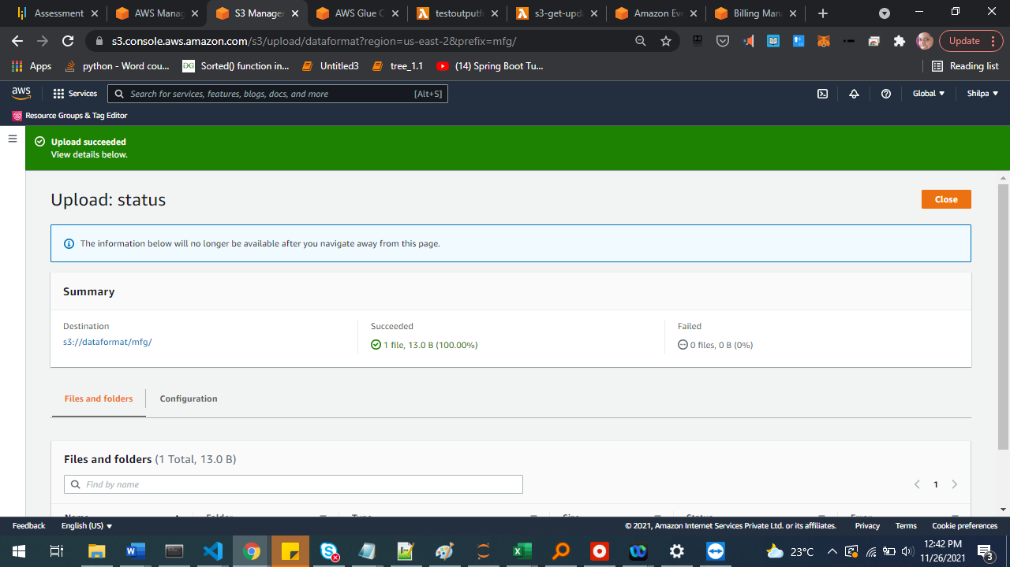

Similarly create some more folders and upload files.

Trigger crawler and check the output:

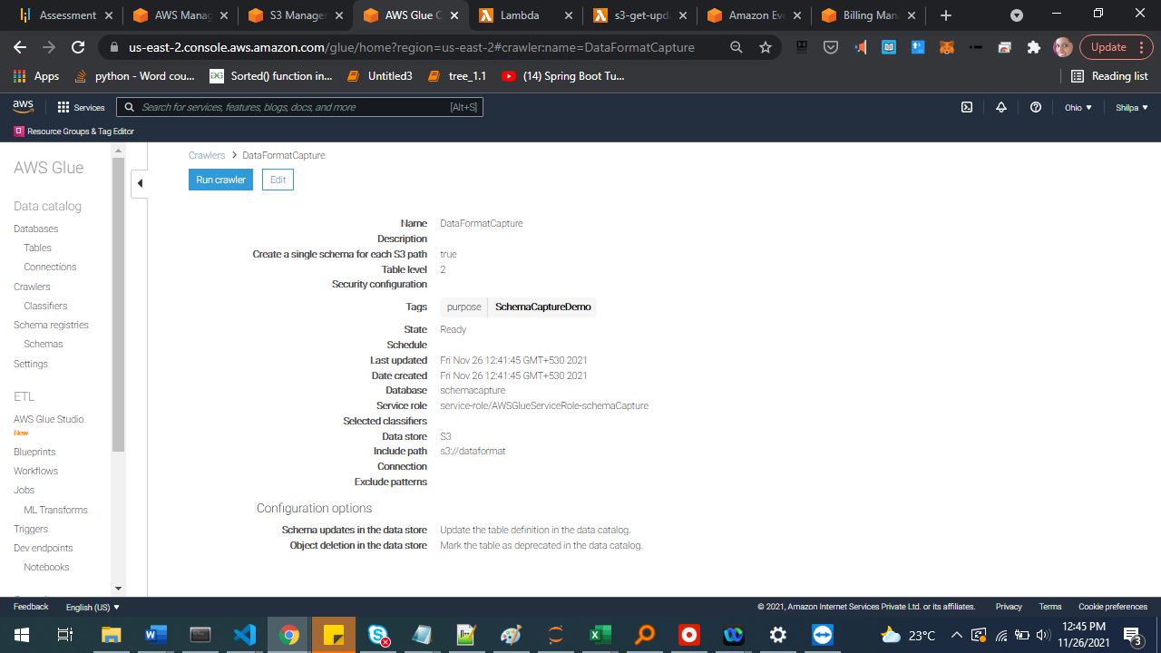

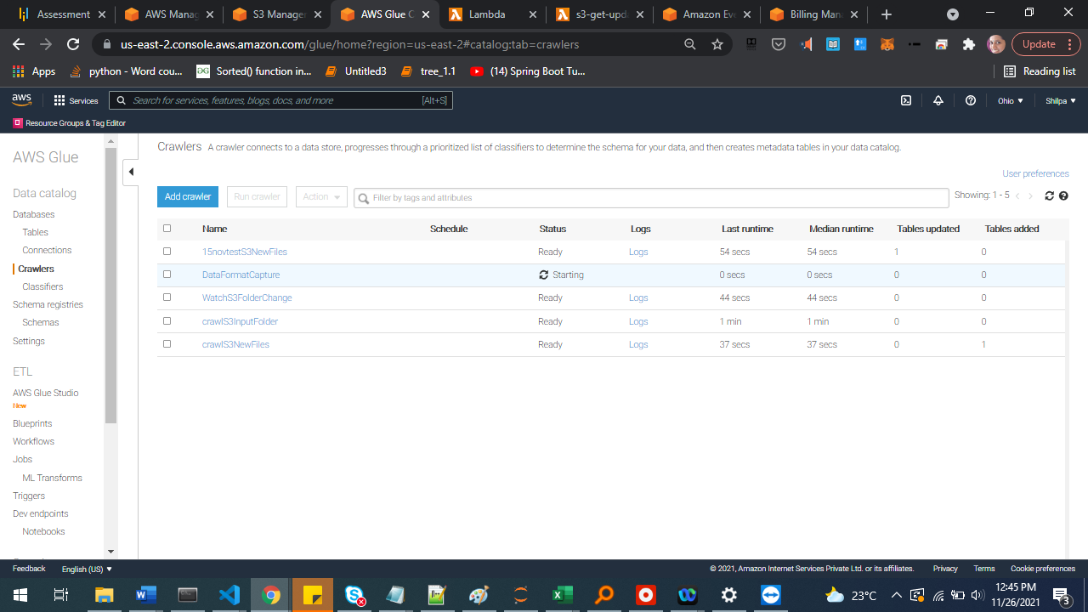

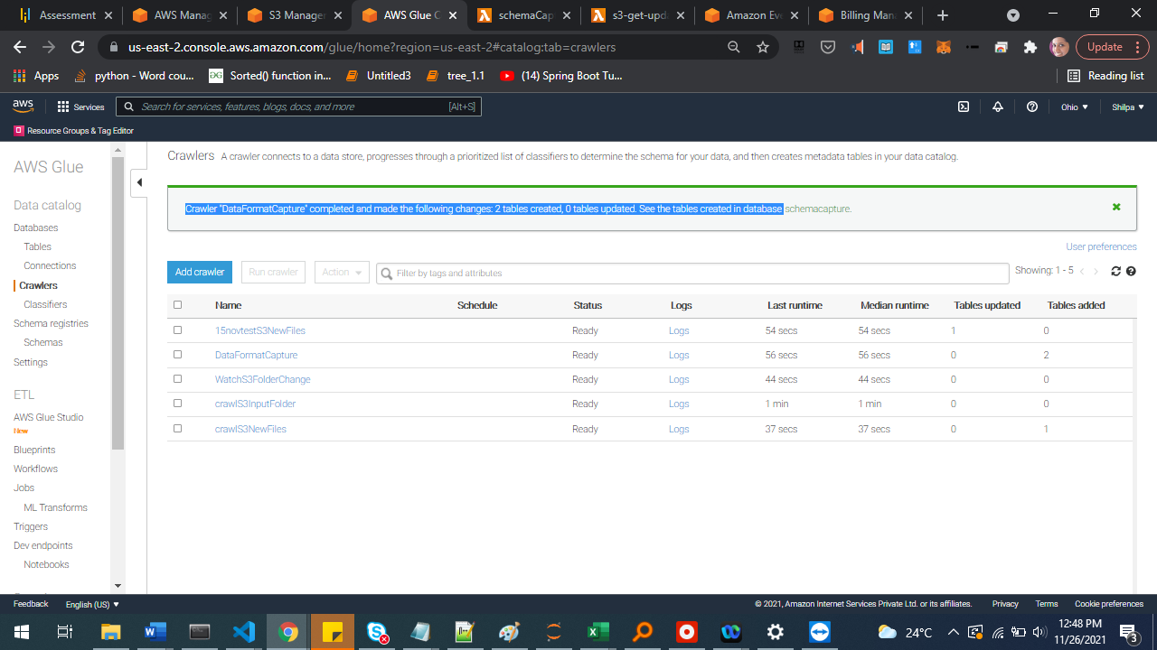

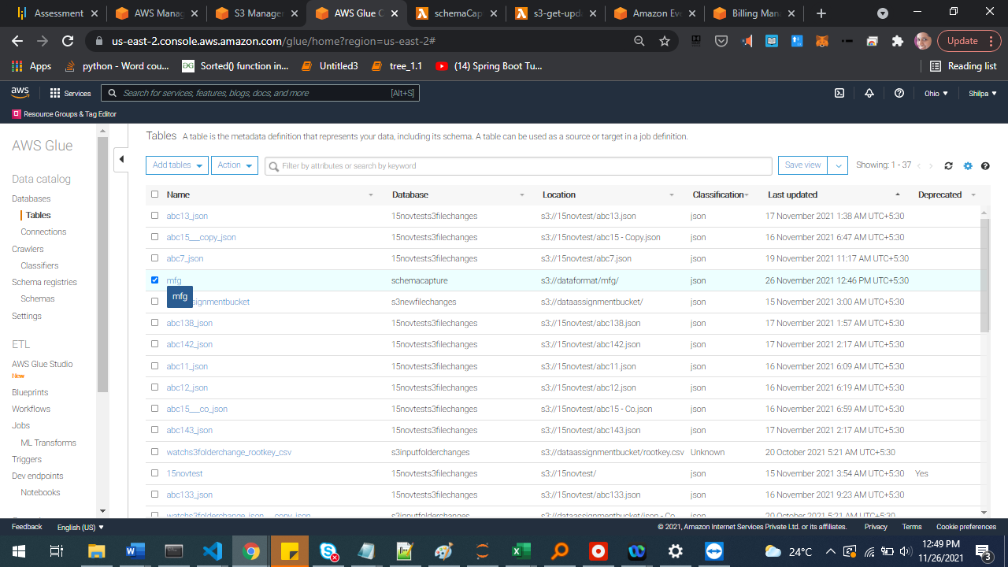

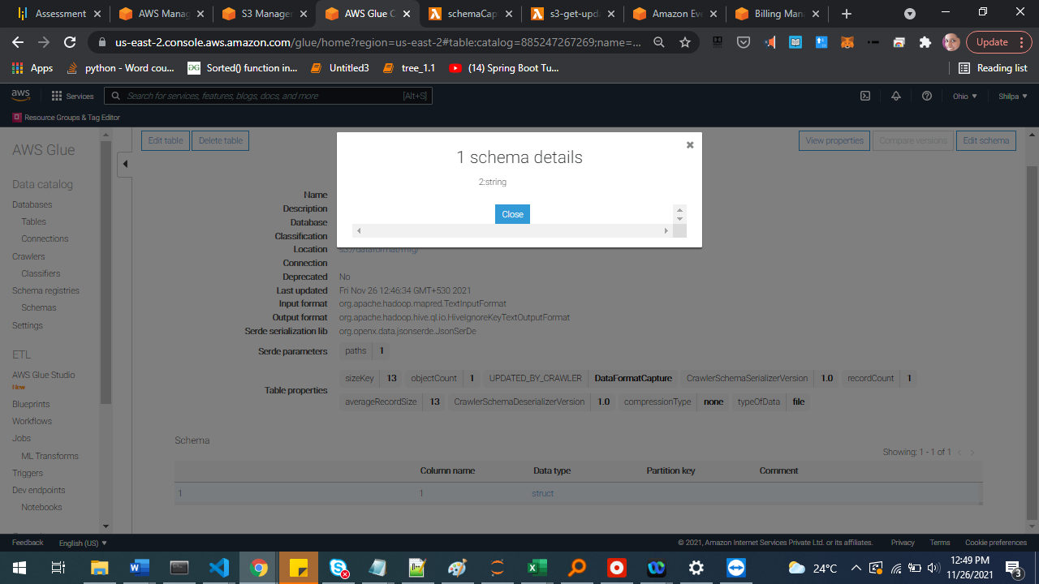

## Lambda function for invoking crawler

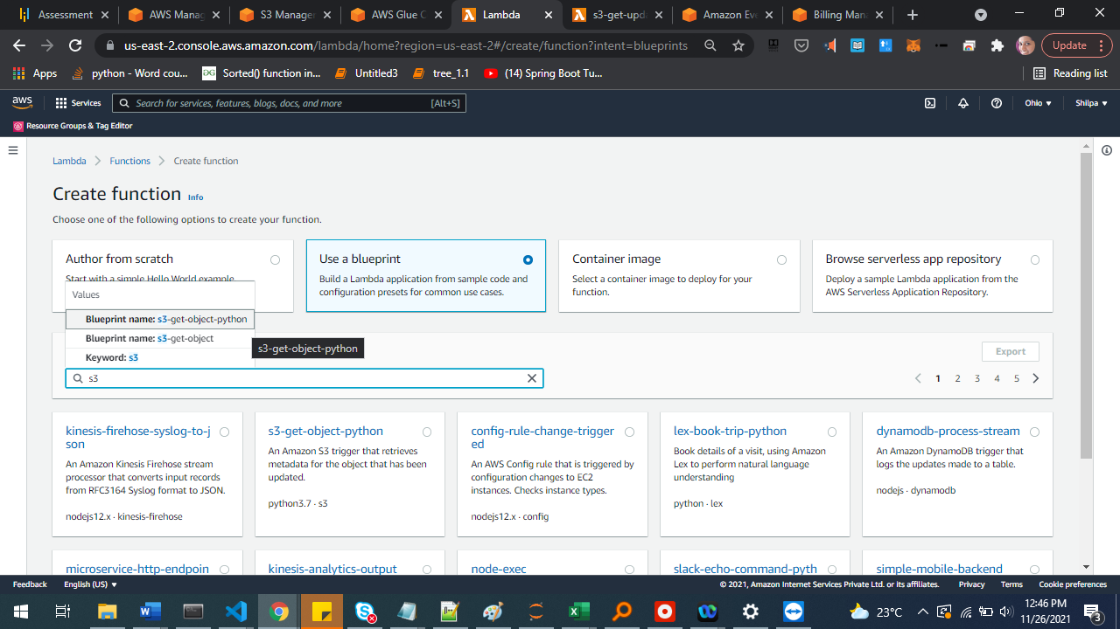

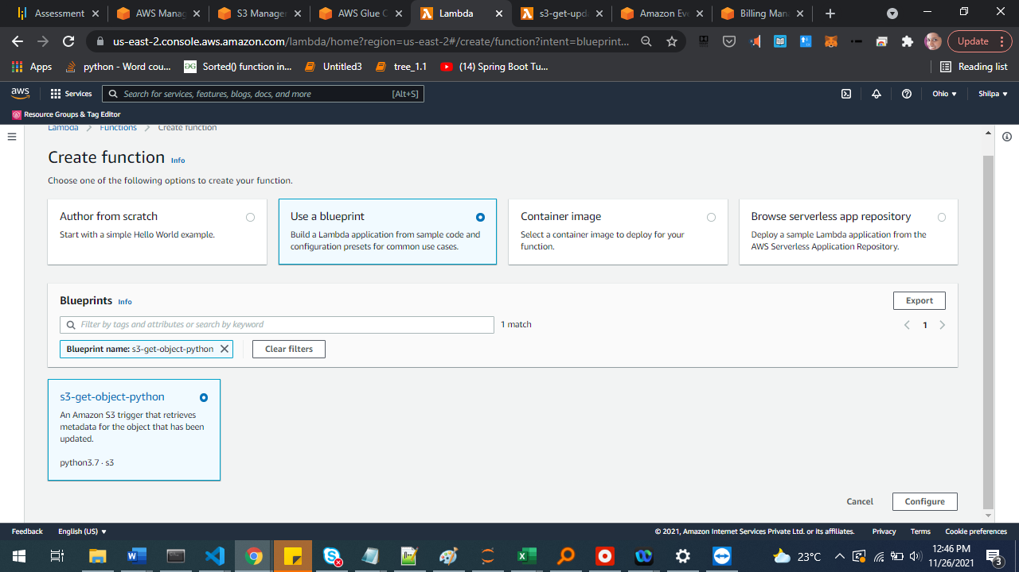

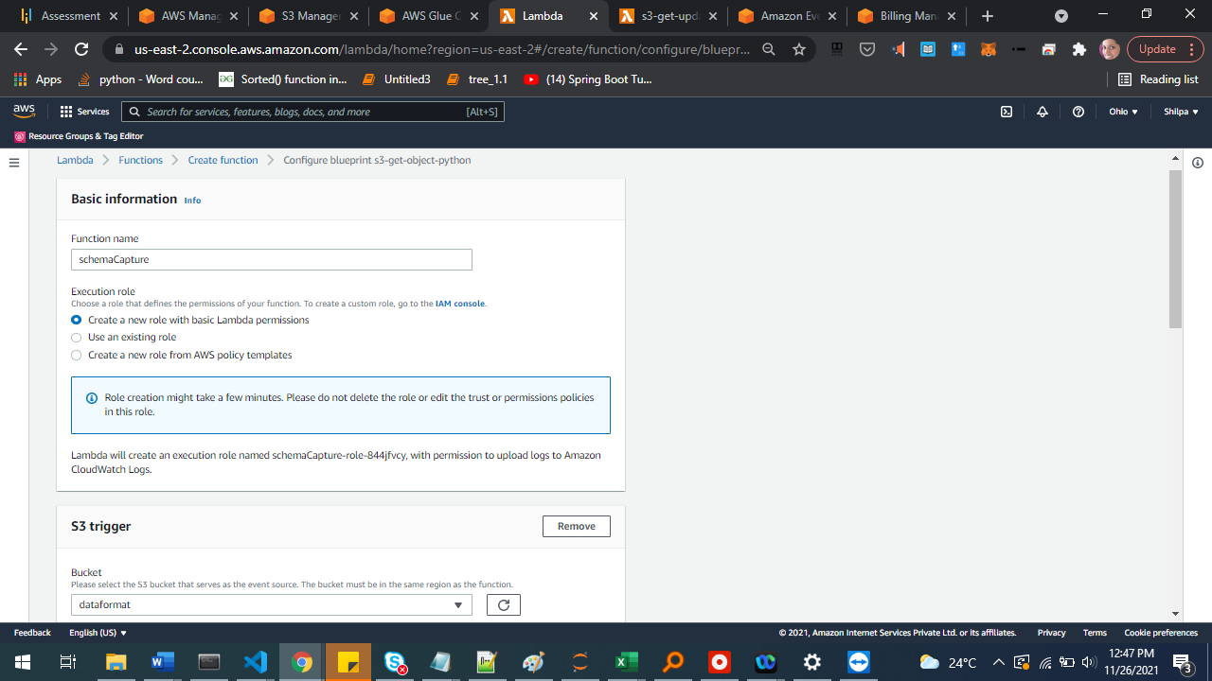

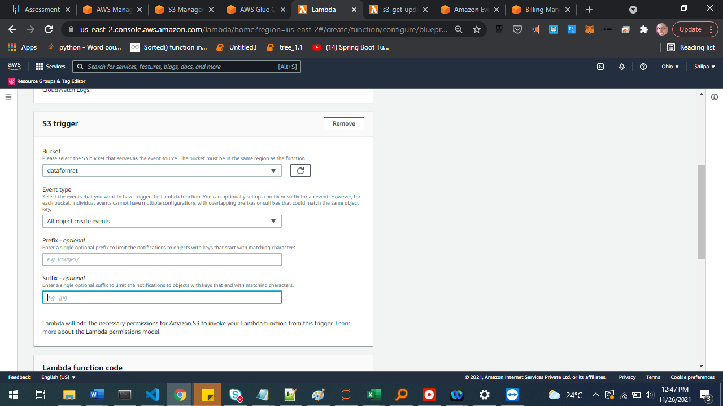

### Add permissions

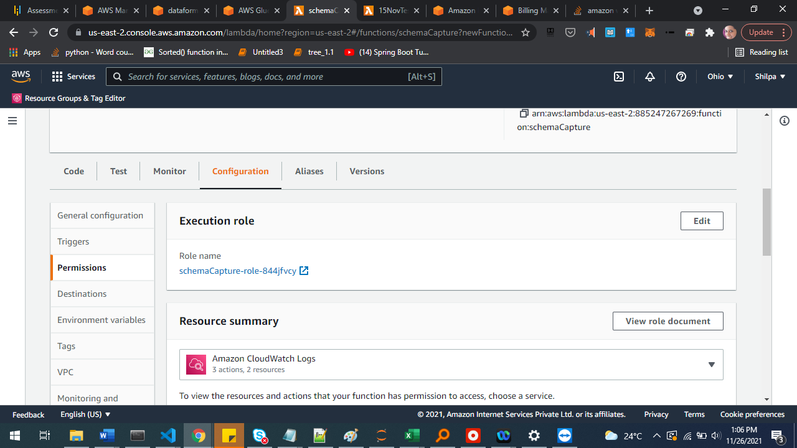

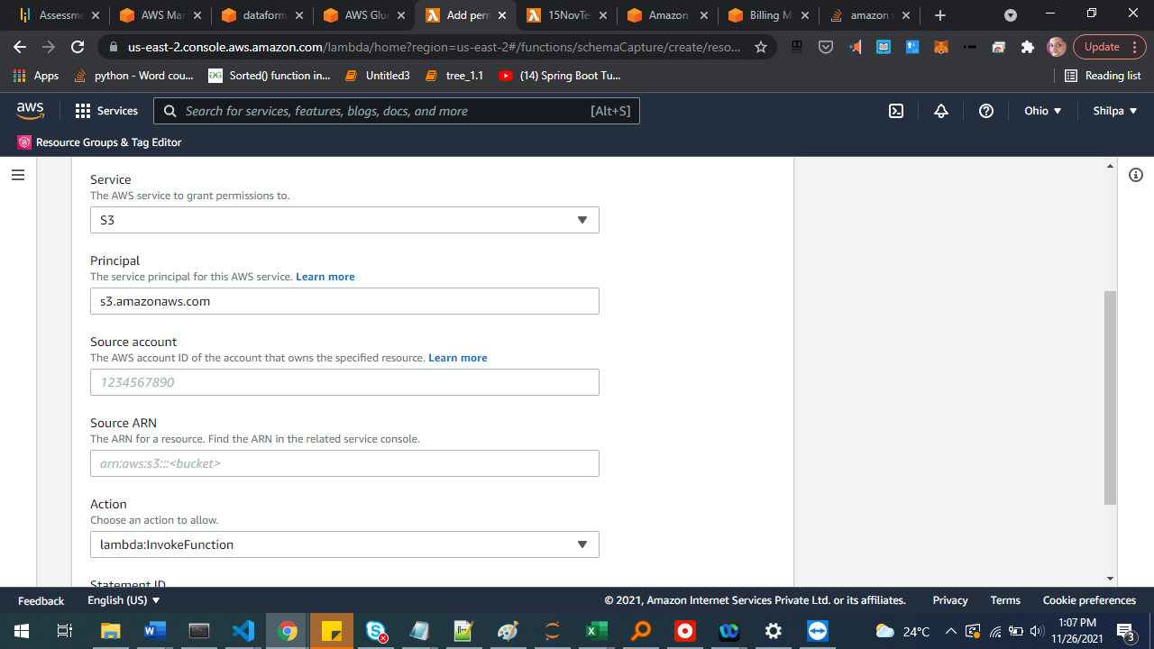

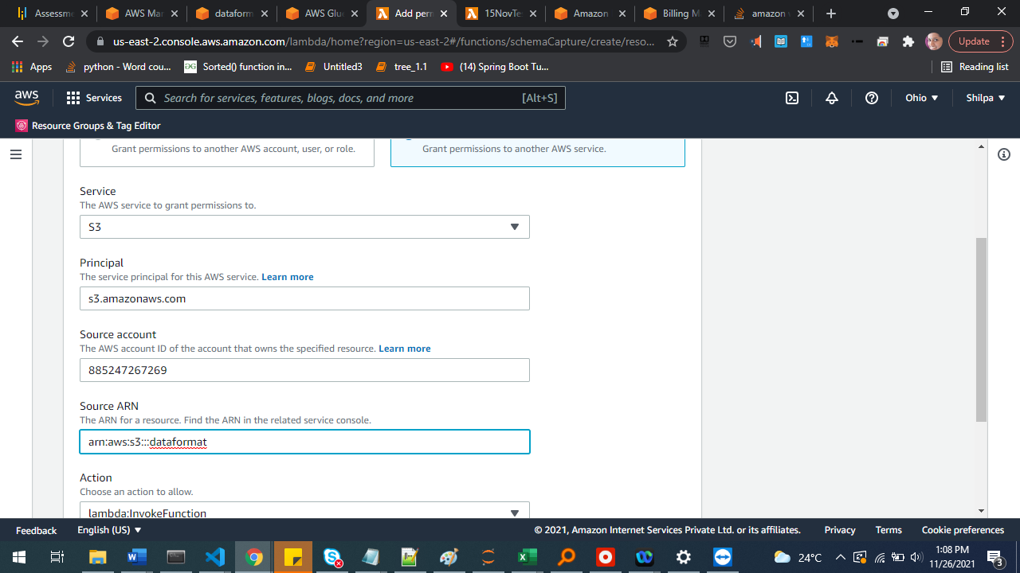

Update IAM role to access S3 and Glue

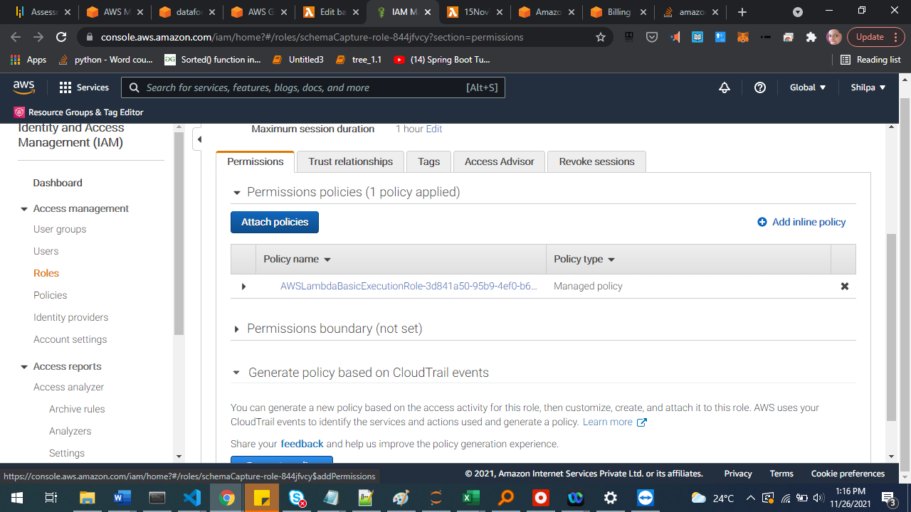

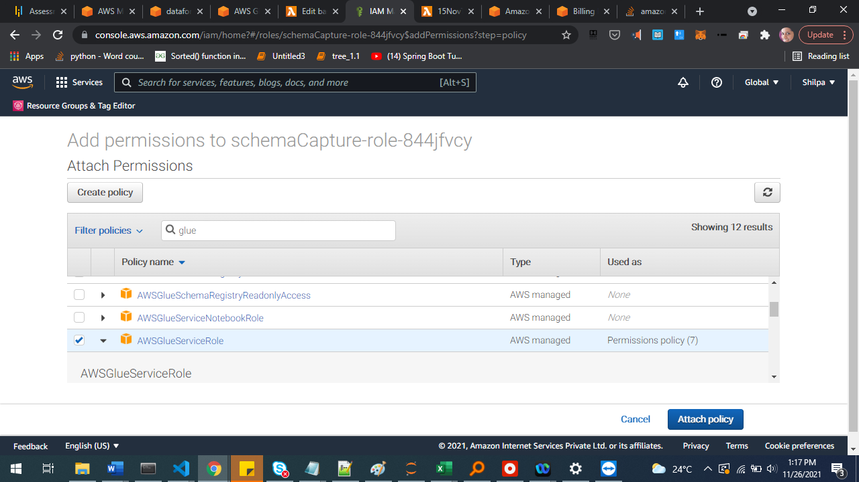

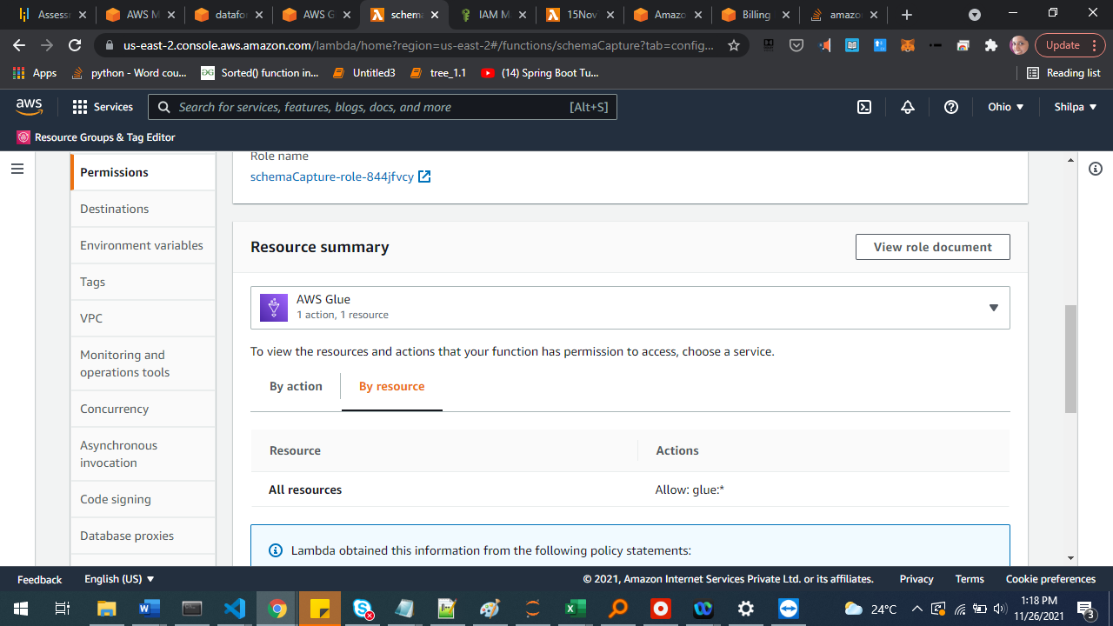

### Add Lambda code

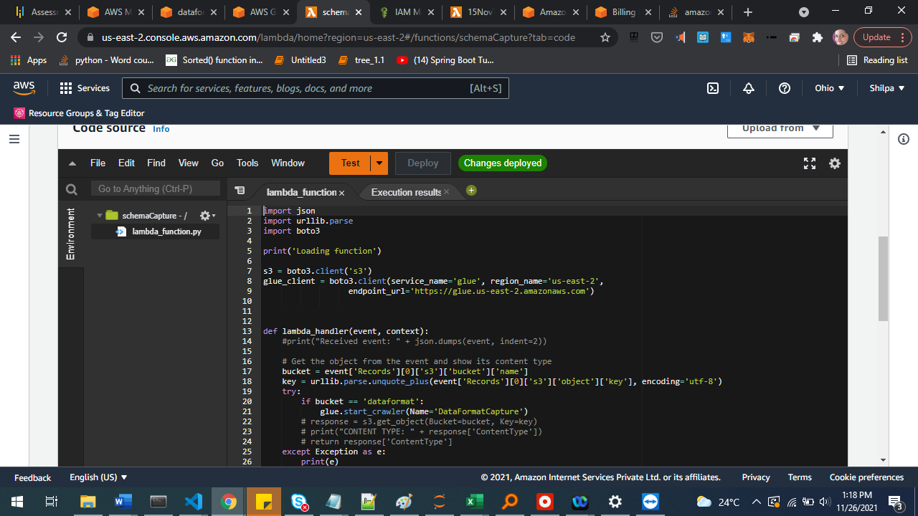

import json

import urllib.parse

import boto3

print('Loading function')

s3 = boto3.client('s3')

glue = boto3.client(service_name='glue', region_name='us-east-2',

endpoint_url='https://glue.us-east-2.amazonaws.com')

def lambda_handler(event, context):

#print("Received event: " + json.dumps(event, indent=2))

# Get the object from the event and show its content type

bucket = event['Records'][0]['s3']['bucket']['name']

key = urllib.parse.unquote_plus(event['Records'][0]['s3']['object']['key'], encoding='utf-8')

try:

if bucket == 'dataformat':

glue.start_crawler(Name='DataFormatCapture')

# response = s3.get_object(Bucket=bucket, Key=key)

# print("CONTENT TYPE: " + response['ContentType'])

# return response['ContentType']

except Exception as e:

print(e)

print('Error getting object {} from bucket {}. Make sure they exist and your bucket is in the same region as this function.'.format(key, bucket))

raise e

### Deploy code change

Configure Lambda test using ‘s3 put’ template and mentioning relevant bucket name in the JSON.

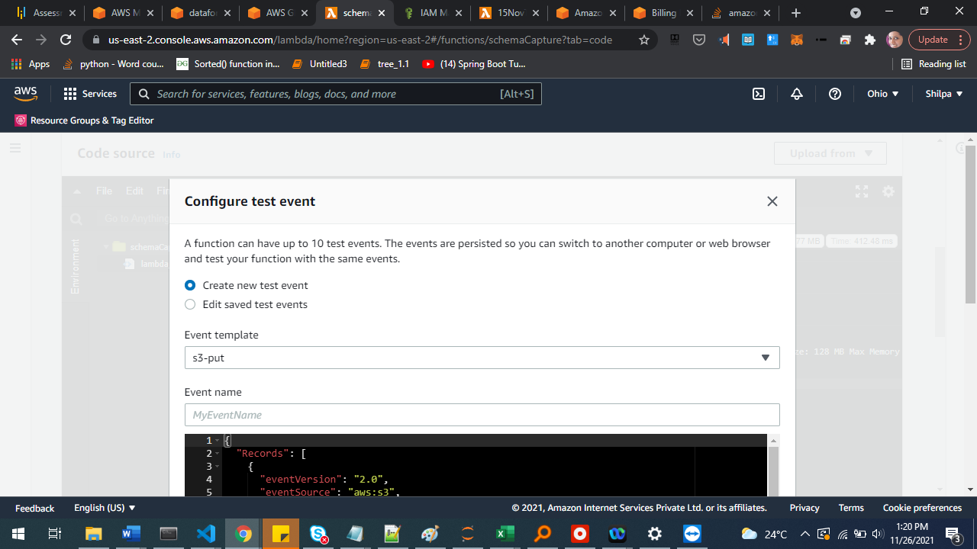

{

"Records": [

{

"eventVersion": "2.0",

"eventSource": "aws:s3",

"awsRegion": "us-east-1",

"eventTime": "1970-01-01T00:00:00.000Z",

"eventName": "ObjectCreated:Put",

"userIdentity": {

"principalId": "EXAMPLE"

},

"requestParameters": {

"sourceIPAddress": "127.0.0.1"

},

"responseElements": {

"x-amz-request-id": "EXAMPLE123456789",

"x-amz-id-2": "EXAMPLE123/5678abcdefghijklambdaisawesome/mnopqrstuvwxyzABCDEFGH"

},

"s3": {

"s3SchemaVersion": "1.0",

"configurationId": "testConfigRule",

"bucket": {

"name": "dataformat",

"ownerIdentity": {

"principalId": "EXAMPLE"

},

"arn": "arn:aws:s3:::example-bucket"

},

"object": {

"key": "test%2Fkey",

"size": 1024,

"eTag": "0123456789abcdef0123456789abcdef",

"sequencer": "0A1B2C3D4E5F678901"

}

}

}

]

}

### Test to see if it works as expected

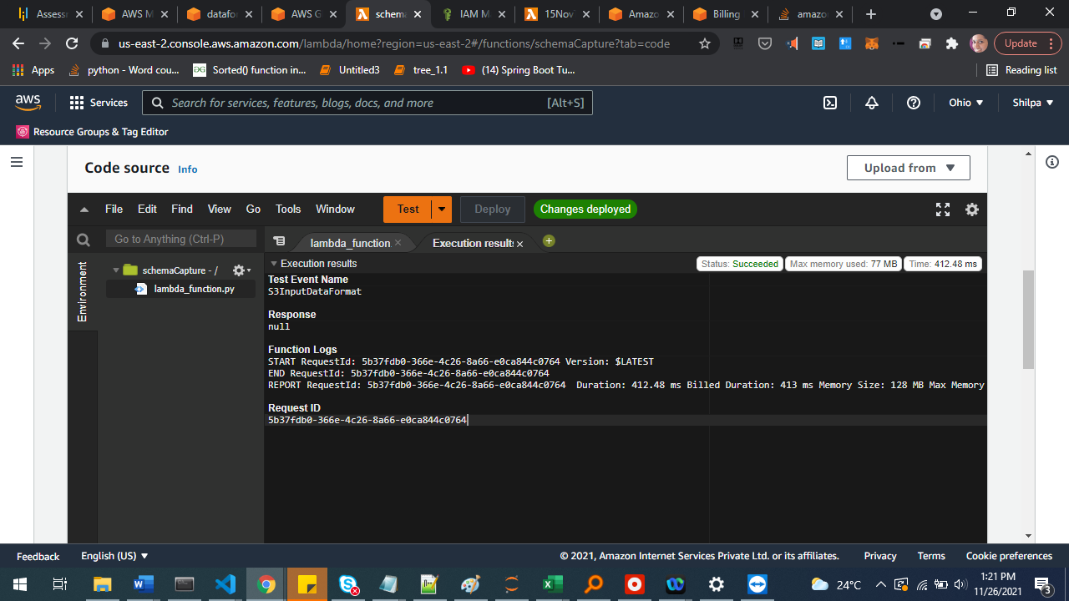

### Add trigger

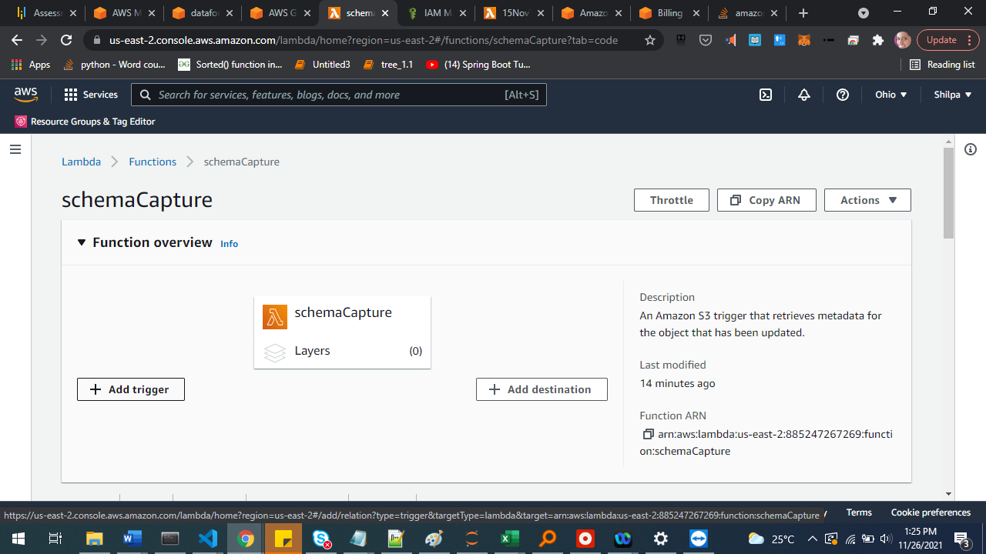

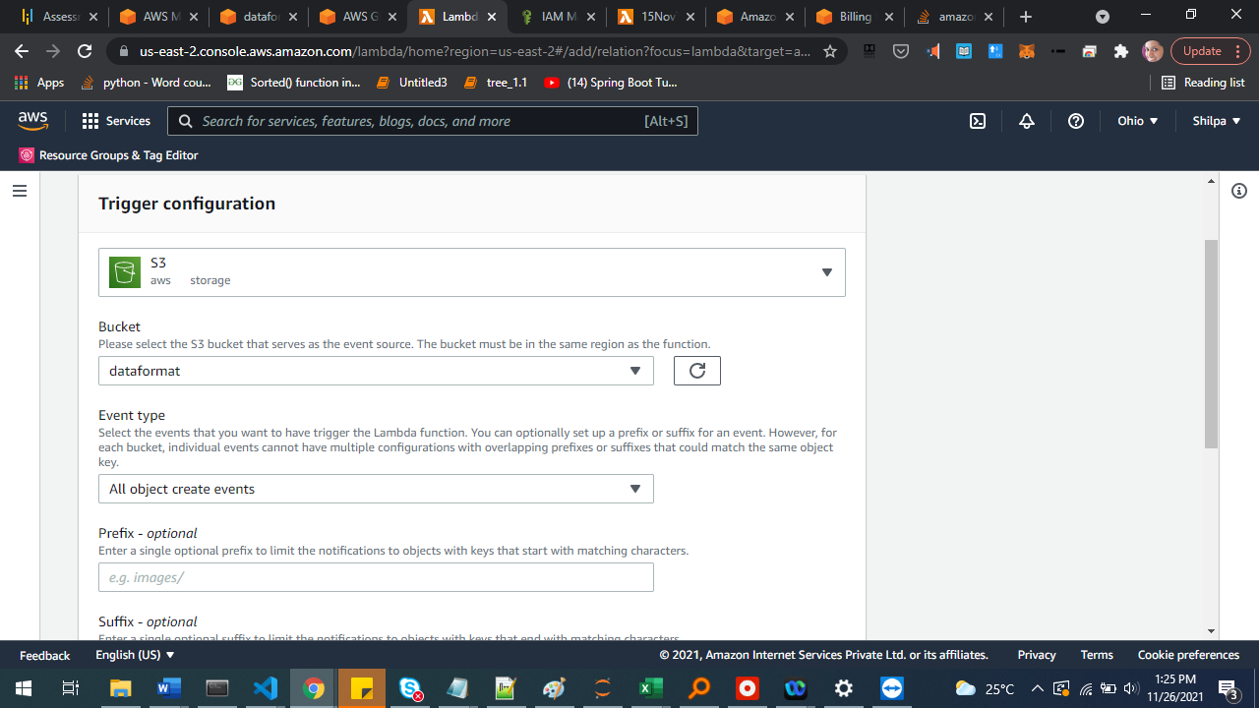

### Test by uploading to S3

Notice that the tables get created as expected.

## DynamoDB

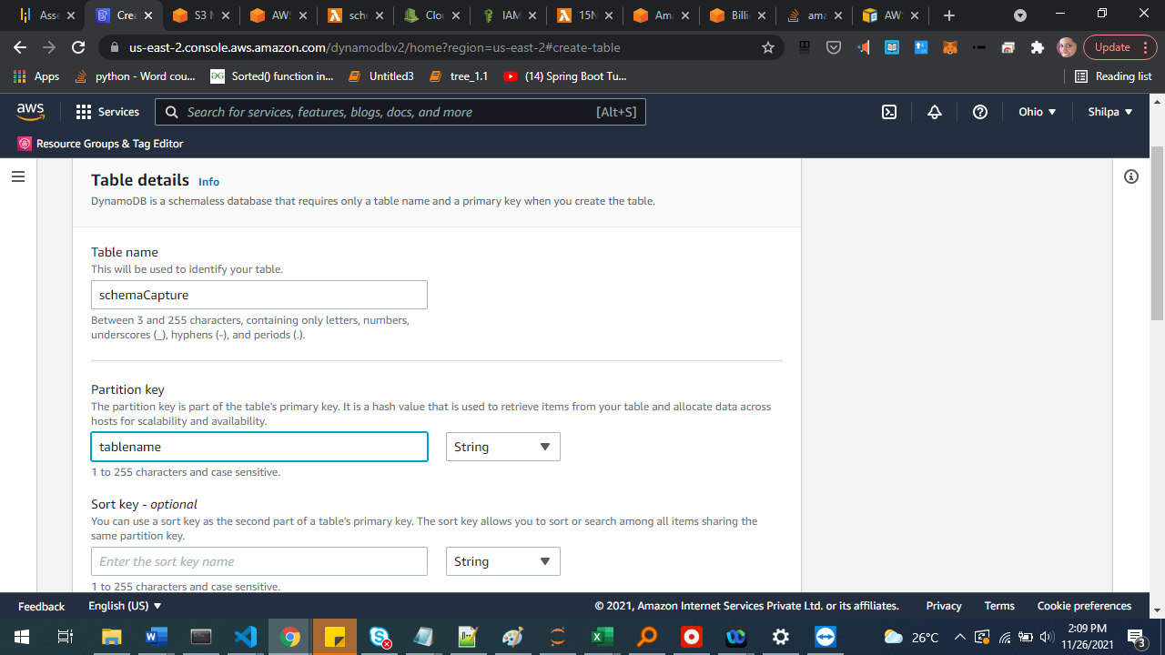

Default configuration

## Lambda to update DynamoDB

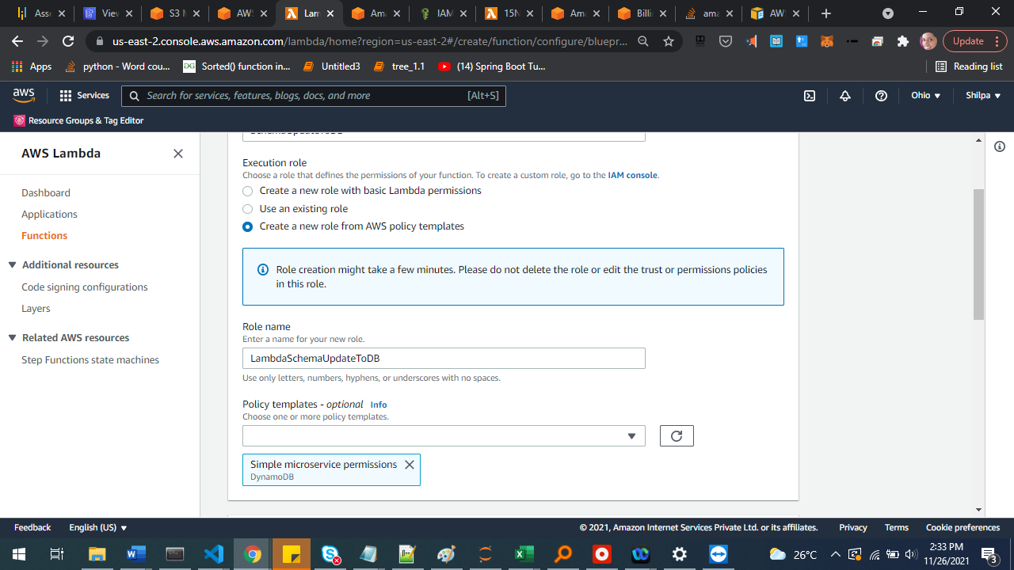

### Update code

Lambda_function.py

import json

import update_schema

def lambda_handler(event, context):

print("Received event: " + json.dumps(event, indent=2))

update_schema.updateSchemaChange(event)

return {

'statusCode': 200,

'body': json.dumps('Done!')

}

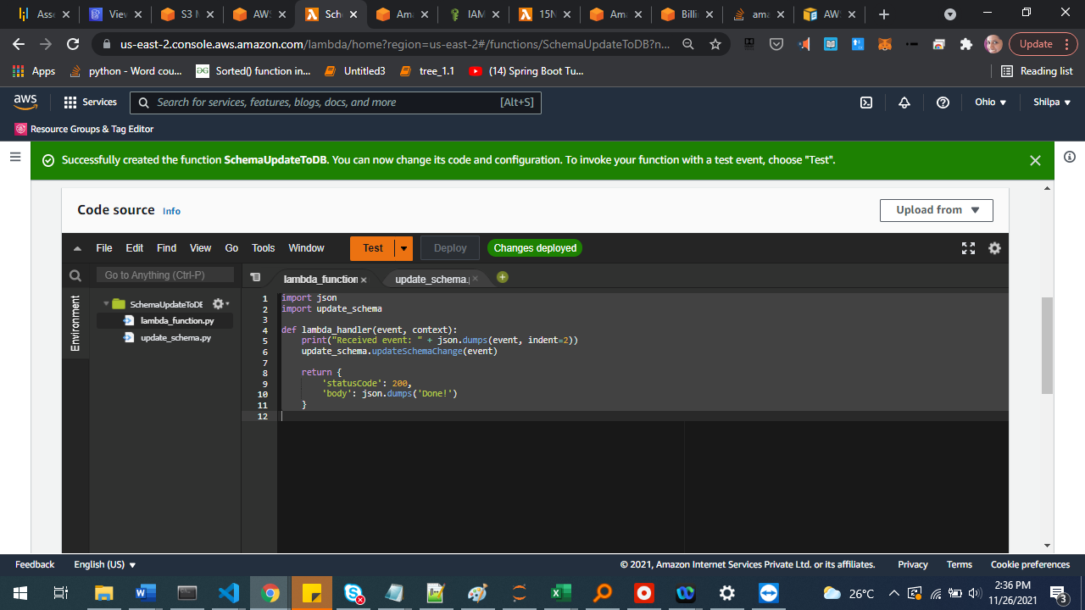

Update_schema.py

import boto3

glue_client = boto3.client(service_name='glue', region_name='us-east-2',

endpoint_url='https://glue.us-east-2.amazonaws.com')

dynamodb_client = boto3.client('dynamodb', region_name='us-east-2')

def updateSchema(tableName):

response = glue_client.get_table( DatabaseName='schemacapture', Name=tableName)

newSchema = str(response['Table']['StorageDescriptor']['Columns'])

createTime = str(response['Table']['CreateTime'])

updateTime = str(response['Table']['UpdateTime'])

print("New Schema: " + newSchema)

print("CreateTime: " + createTime)

print("UpdateTime: " + updateTime)

try:

print("Table name:", tableName)

table_dict = dynamodb_client.get_item(TableName='schemaCapture',Key={'tableName':{'S':tableName}})

oldSchema = table_dict['Item']['newSchema']['S']

print("Old schema: ", oldSchema)

except Exception as e:

print(e)

response = dynamodb_client.put_item(TableName='schemaCapture', Item={'tableName':{'S':tableName},"newSchema":{"S":newSchema},"updateTime":{"S":updateTime},"createTime":{"S":createTime}})

print("Created new one. "+ str(response))

else:

dynamodb_client.update_item(TableName='schemaCapture', Key={'tableName':{'S':tableName}}, AttributeUpdates={"newSchema":{"Action":"PUT","Value":{"S":newSchema}},"oldSchema":{"Action":"PUT","Value":{"S":oldSchema}},"updateTime":{"Action":"PUT","Value":{"S":updateTime}}})

print("Updated current one")

def updateSchemaChange(event):

try:

if event['detail-type'] == 'Glue Data Catalog Table State Change':

tableName = str(event['detail']['tableName'])

print("Changed Table name : " + tableName)

updateSchema(tableName)

elif event['detail-type'] == 'Glue Data Catalog Database State Change':

tables = (event['detail']['changedTables'])

print("New Tables : " + str(tables))

for tableName in tables:

updateSchema(tableName)

except Exception as e:

print(e)

print('Error')

raise e

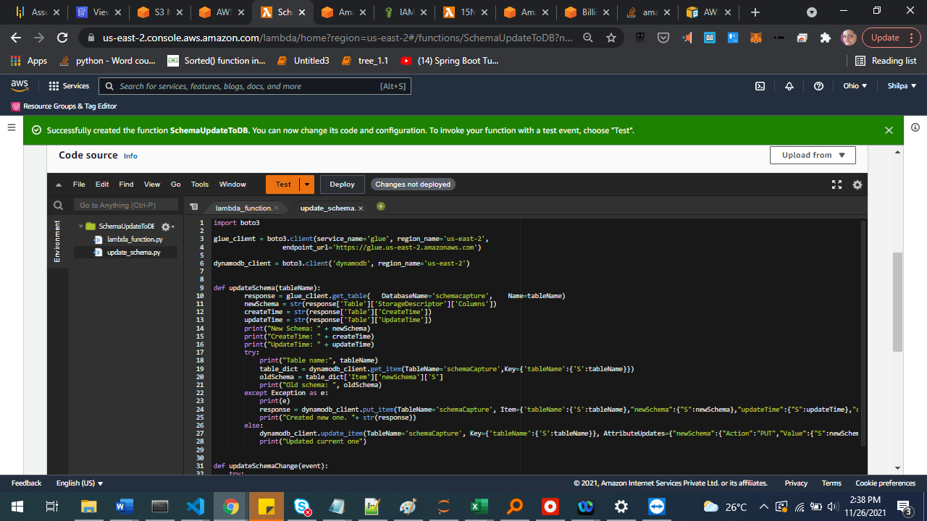

Deploy changes by clicking Deploy button

Create test configuration:

For new table:

{

"version": "0",

"id": "d516cf4b-0e9b-ddec-2787-9bb3a44b0780",

"detail-type": "Glue Data Catalog Database State Change",

"source": "aws.glue",

"account": "885247267269",

"time": "2021-11-16T17:01:02Z",

"region": "us-east-2",

"resources": [

"arn:aws:glue:us-east-2:885247267269:table/schemacapture/test___scm5_json"

],

"detail": {

"databaseName": "schemacapture",

"typeOfChange": "CreateTable",

"changedTables": [

"test___scm5_json"

]

}

}

For existing table:

{

"version": "0",

"id": "00000000-715f-0000-70b8-d210da0317a0",

"detail-type": "Glue Data Catalog Table State Change",

"source": "aws.glue",

"account": "123456789012",

"time": "2019-01-16T18:16:01Z",

"region": "us-east-1",

"resources": [

"arn:aws:glue:us-east-1:123456789012:table/schemacapture/mfg"

],

"detail": {

"databaseName": "schemacapture",

"changedPartitions": [

"[C.pdf, dir3]",

"[D.doc, dir4]"

],

"typeOfChange": "BatchCreatePartition",

"tableName": "mfg"

}

}

### Edit role to add permission to Glue and DynamoDB:

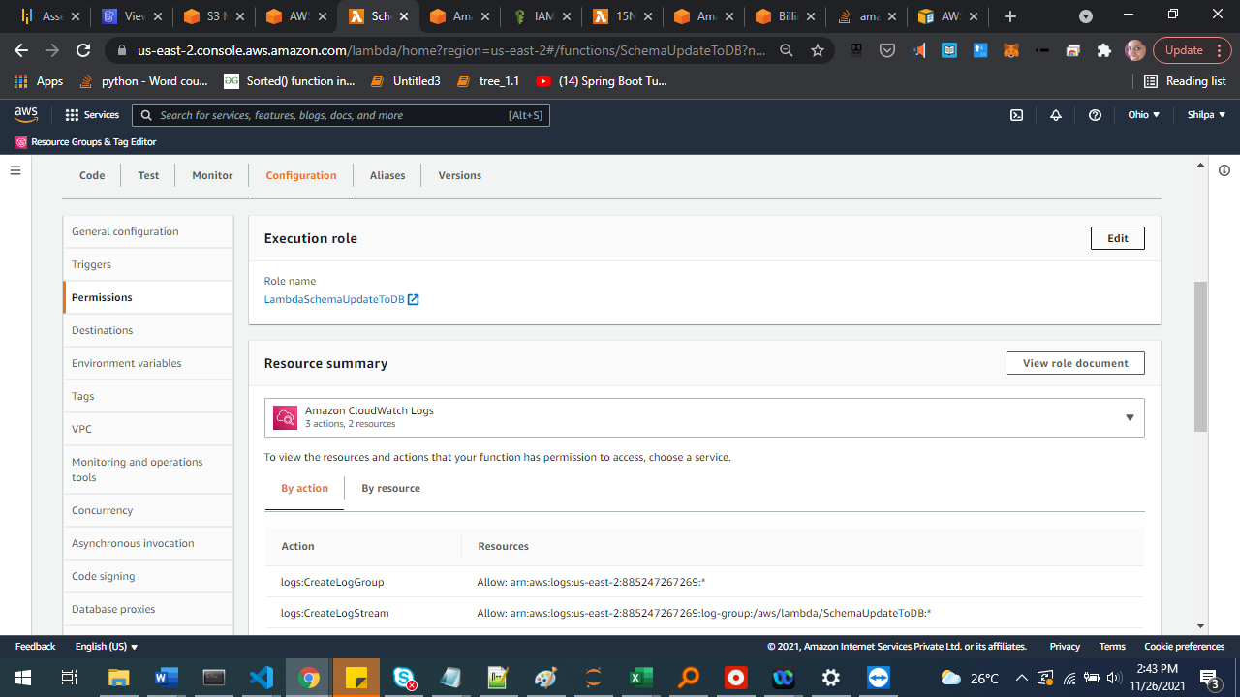

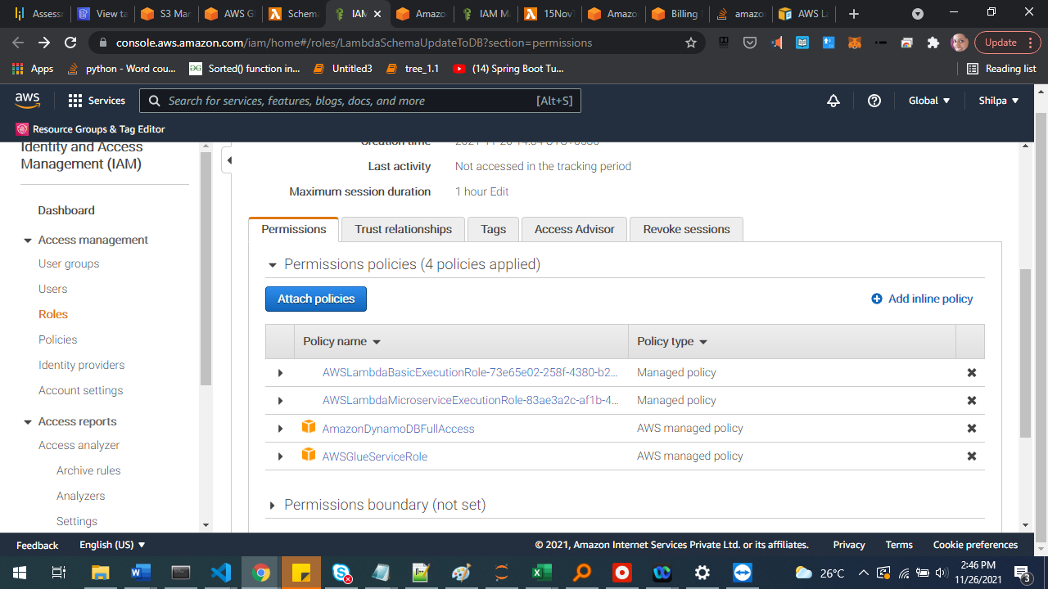

### Test event

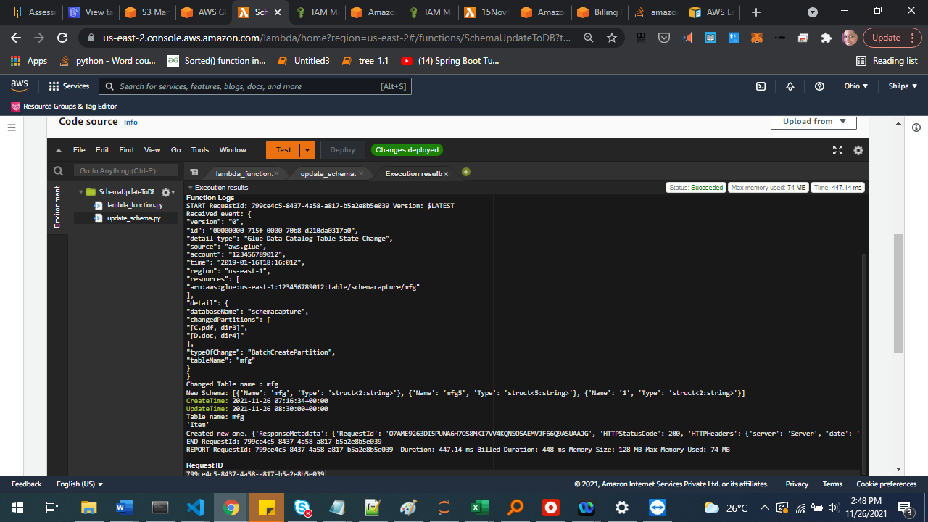

Confirm in DynamoDB:

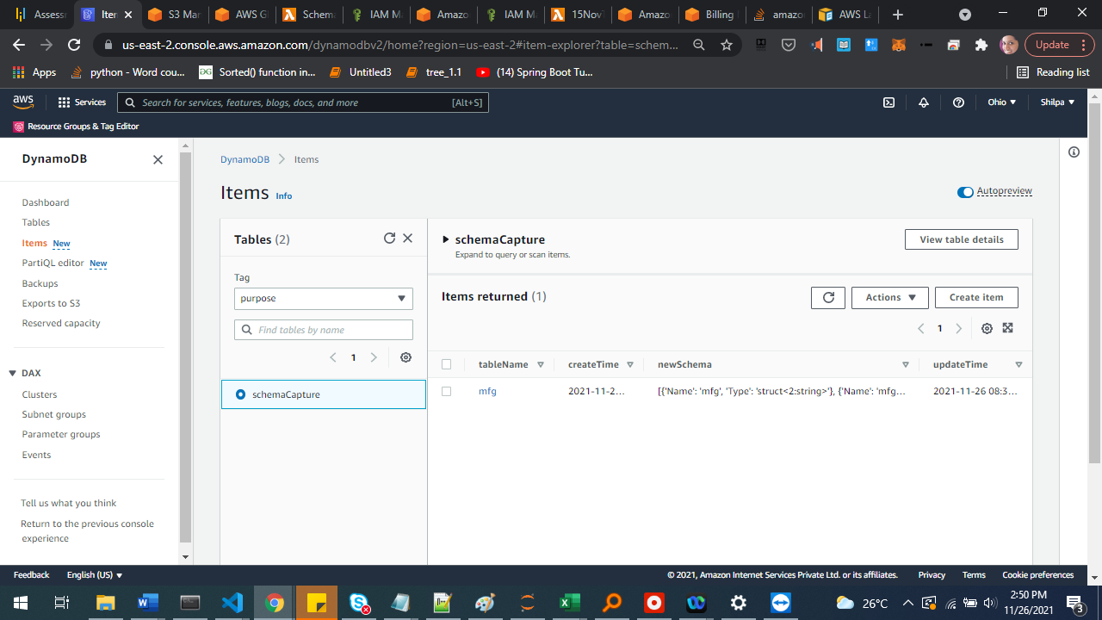

## EventBridge rules

Create EventBridge rules to capture table creation and updates

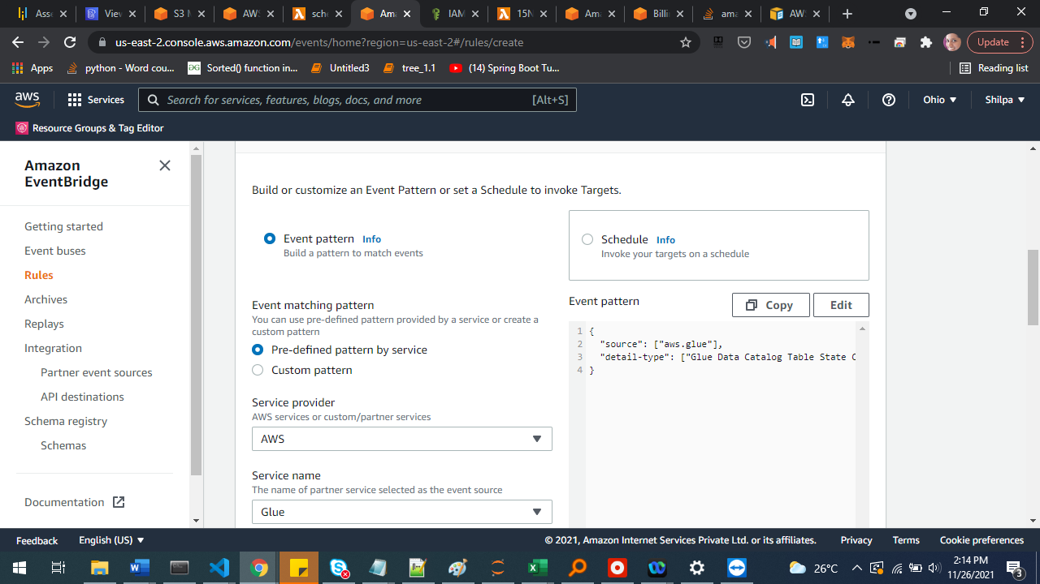

View sample event and update the event pattern JSON based on our need:

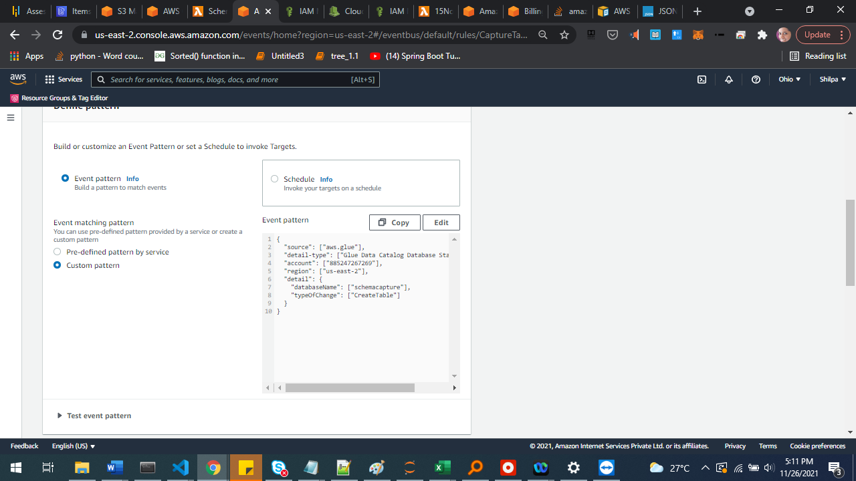

{

"source": ["aws.glue"],

"detail-type": ["Glue Data Catalog Database State Change"],

"account": ["885247267269"],

"region": ["us-east-2"],

"detail": {

"databaseName": ["schemacapture"],

"typeOfChange": ["CreateTable"]

}

}

Select target Lambda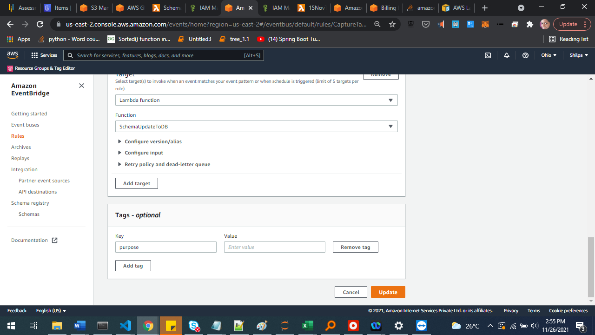

Same for table updates

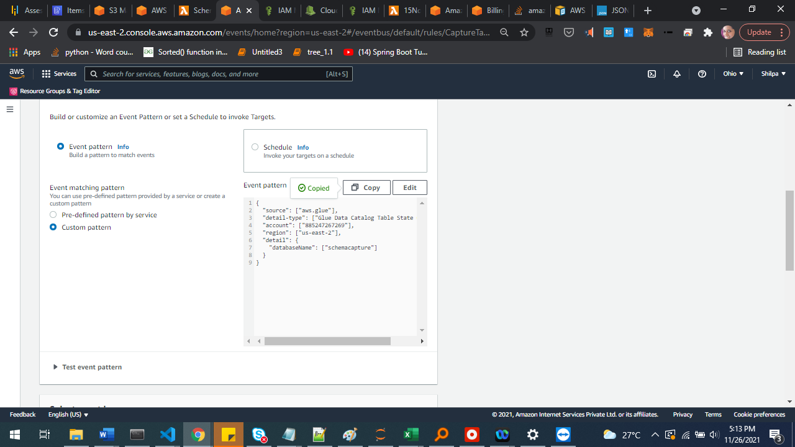

{

"source": ["aws.glue"],

"detail-type": ["Glue Data Catalog Table State Change"],

"account": ["885247267269"],

"region": ["us-east-2"],

"detail": {

"databaseName": ["schemacapture"]

}

}

## Notes

* All necessary permissions should be present for the role you use
* All services should be ensured to be present in the expected region for availability.
* In Glue Crawler, it can be configured to use the same schema for all files in a single schema. But each filename will have a separate row in the Glue Catalog table. If same filename is present in different folders, it still won’t converge to one file as it belongs to a different schema.